**Lab Exercise 9– Creating Replicaset in Kubernetes**

Below is a lab exercise that will help you understand and practice creating a Replicaset in Kubernetes:

**Step 1: Create a ReplicaSet Configuration File**

Create a file named replicaset.yaml with the following configuration:

Link of file: (Coly following code from my GitHub repo)

<https://github.com/hkshitesh/ACO-LAB-2021-25/blob/main/scripts/replicaset.yaml>

apiVersion: apps/v1

kind: ReplicaSet

metadata:

name: my-nginx-rs

spec:

replicas: 3

selector:

matchLabels:

app: lbnginx

template:

metadata:

labels:

app: lbnginx

spec:

containers:

- name: nginx

image: nginx

**Step 2: Apply the ReplicaSet Configuration**

Apply the configuration to create the ReplicaSet:

kubectl apply -f replicaset.yaml

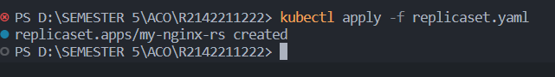

**Step 3: View the ReplicaSet and Pods**

View the created ReplicaSet and the associated Pods:

kubectl get replicaset

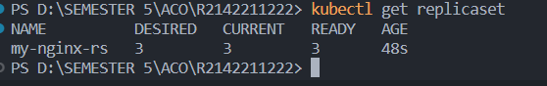

kubectl get pods

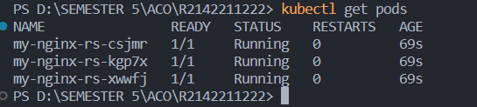

**Step 4: Scale the ReplicaSet**

Scale the ReplicaSet to 5 replicas:

kubectl scale replicaset my-nginx-rs --replicas=5



**Step 5: Delete the ReplicaSet**

Delete the ReplicaSet:

kubectl delete replicaset my-replicaset



**Conclusion**

This exercise demonstrated how to create, manage, and update a ReplicaSet in Kubernetes. You learned how to scale the ReplicaSet, update the image, and delete the ReplicaSet from the cluster. Experiment further with different configurations and scaling options to deepen your understanding of managing ReplicaSets in Kubernetes.